National University of Computer and Emerging Sciences



# Lab Manual 9

**Operating System Lab**

|  |  |
| --- | --- |
| Course Instructor | Ms. Namra Absar |
| Lab Instructor(s) | Saba Tariq |
| Section | BCS 4A |
| Semester | Spring 2024 |

Department of Computer Science

FAST-NU, Lahore, Pakistan

A semaphore is a synchronization primitive that controls access to shared resources by multiple processes or threads. It maintains a counter and supports two fundamental operations:

* **Wait (P) Operation**: Decrements the semaphore value. If the semaphore value is non-negative, the decrement proceeds, and the process continues. If the semaphore value becomes negative (i.e., no more resources available), the process is blocked until another process increments the semaphore.
* **Signal (V) Operation**: Increments the semaphore value. If any processes were blocked waiting for this semaphore, one of them is allowed to proceed.

**POSIX Semaphores**

POSIX (Portable Operating System Interface) semaphores are a standardized form of semaphores available on Unix and Linux systems. They provide a way to synchronize processes (including unrelated processes) using named semaphores. POSIX semaphores are part of the POSIX Threads (pthreads) library (**libpthread**).

**Key Functions for POSIX Semaphores**

**1. sem_open**

#include <semaphore.h>

sem_t *sem_open(const char *name, int oflag, mode_t mode, unsigned int value);

* Opens or creates a named semaphore.
* **name**: Name of the semaphore (must start with a **/** character).
* **oflag**: Flags indicating the mode of operation (**O_CREAT** for creating if not existing, **O_EXCL** to ensure creation fails if the semaphore already exists).
* **mode**: Permissions for the semaphore if created (**0644** is commonly used).
* **value**: Initial value of the semaphore.

**2. sem_wait**

#include <semaphore.h>

int sem_wait(sem_t *sem);

* Waits (P operation) on the semaphore.
* Decrements the semaphore value.
* Blocks if the semaphore value is zero (no resources available).

**3. sem_post**

#include <semaphore.h>

int sem_post(sem_t *sem);

* Signals (V operation) on the semaphore.
* Increments the semaphore value.
* Unblocks one of the waiting processes (if any).

**4. sem_close**

#include <semaphore.h>

int sem_close(sem_t *sem);

* Closes the named semaphore.
* Releases the associated resources.
* After closing, the semaphore can no longer be used by the process.

**5. sem_unlink**

#include <semaphore.h>

int sem_unlink(const char *name);

* Removes a named semaphore from the system.
* The semaphore can no longer be opened or used after unlinking.
* This is typically done after all processes using the semaphore have finished.

Example 1:

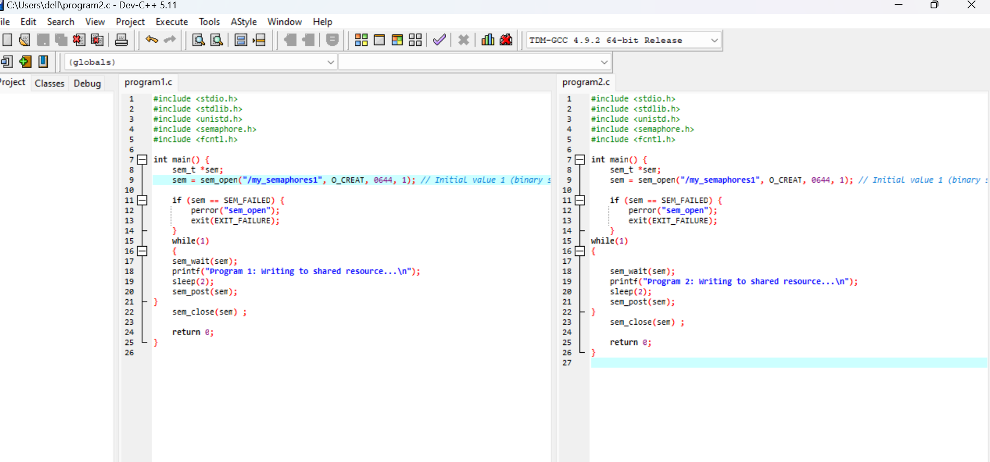

Output:

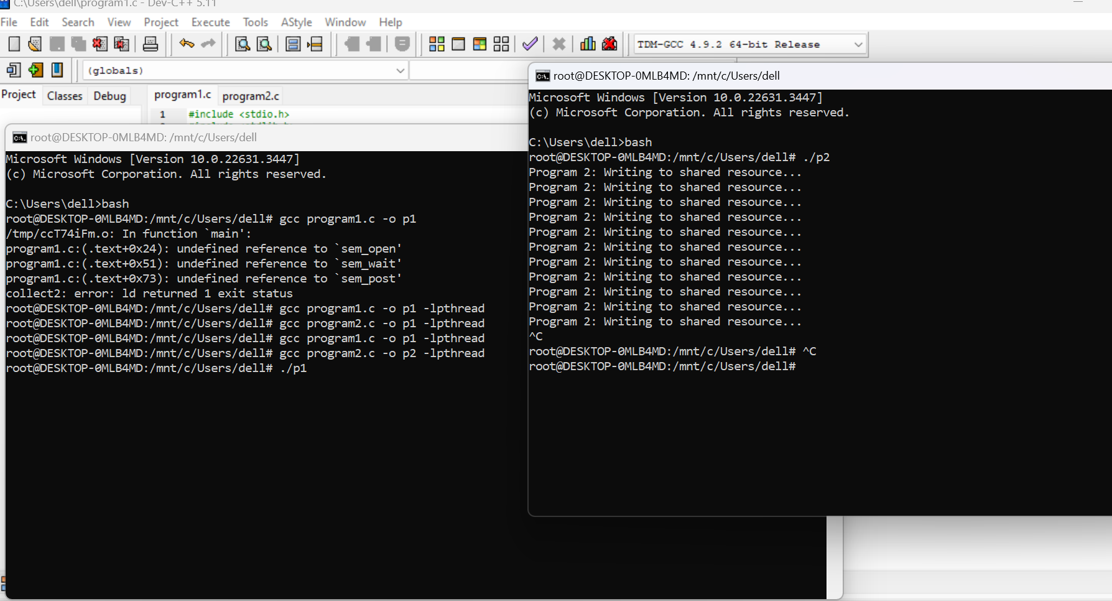

Example 2:

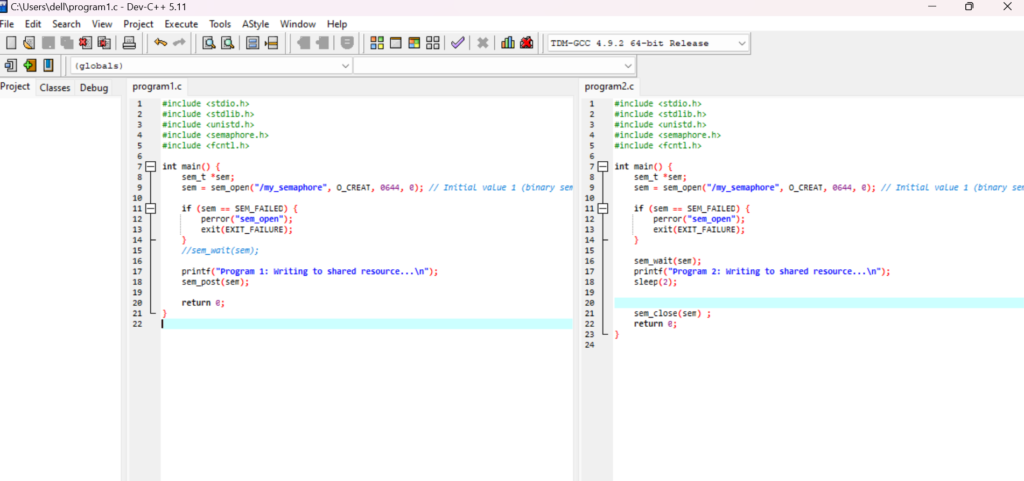

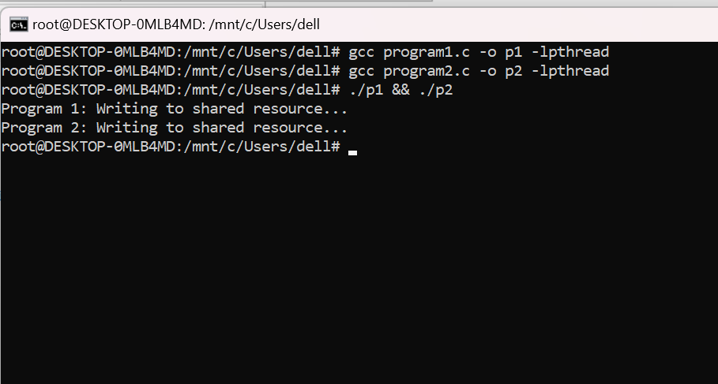 Output 2:

Question: Consider a scenario where three processes (**P1**, **P2**, **P3**) need to execute in a specific order while sharing a common resource (file) that requires mutual exclusion. Use semaphores to ensure that the processes execute in the sequence **P1 -> P2 -> P3** and have exclusive access to the shared resource when needed.

* P1 opens a file having all integers and calculate their sum and write it into the same file.
* After that P2 counts the integers and also write it in the same file.
* P3 reads sum and count from this file calculated by P1 and P2 and calculates average and print it on the screen.